Conditions of Sale

Agent Rebate
Nutrien Ag Solutions is the conducting agent for our 2022 sale with a 4% rebate to Inverbrackie approved outside agents attending the sale and providing written notification of client details before the close of business on the 11th October 2022.

GST
There is no GST on lots: 1006, 1014, 1057, 1098, 1102, 1105, 1115, 1133, 1139, 1142, 1150, 1176, 1189, 1190, 1193 and 1314.

Stud Registration
Rams purchased by studs that require registration will attract a minimum price of $4000

Semen Rights
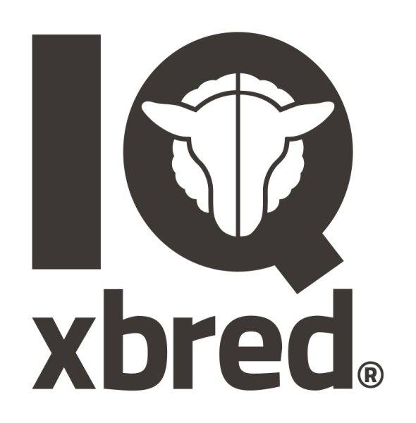
CE & LJ Arney are selling the physical possession of rams to individuals and /or syndicate members and retain 100% semen marketing rights on all Inverbrackie rams . Semen may be collected and used by the initial purchaser/s of any ram.

Integrity
We have high standards for things that are under our control like biosecurity and animal health. However there some things like ram libido and ram fertility that we have no control over. In event of an issue arising with any ram we have sold please contact us promptly. We limit our liability to purchase price of the ram or a voucher to purchase a replacement ram to the same value in the next Inverbrackie ram sale.

In the event of unforeseen circumstances a ram may be withdrawn from the sale and another ram may or may not be offered in their place. Data for replacement rams will be displayed on the pen at the sale.
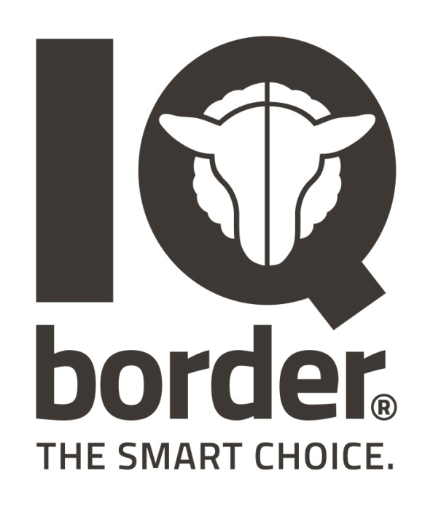

IQ Border is registered for use with the Border Leicester rams that are produced by Inverbrackie Border Leicester Stud. In the ram sale the rams that carry our pink lot number eartag carry our reputation. The lot number begins with the year of birth so that if the same lot number was purchased by the same person in different years it is still easily identified from a distance.

IQ is short for Inverbrackie Quality

IQ xbred is registered for use to label the progeny of IQ Border rams bred with Merino ewes. The use of the logo is permitted with approval from Inverbrackie when it can be assured that the progeny both ewe and wethers are produced solely from Inverbrackie rams. We are constantly told that the Inverbrackie sired 1st cross lambs are different and perform very well.

